

Nursing Home Assessment Provider Assessments Application

Provider Portal Login

User Guide

Document Version: V4 May 31, 2024

Contents
1. Introduction 3
1.1 What is the Provider Portal? 3
1.1.1 Requirements for Accessing the Provider Portal 3
1.2 Requesting a NCID Login and Accessing the Provider Portal 3
1.2.1 Setting Up Provider Rep User Profile: First Time Logging In 6
1.2.2 What a NHA Provider Representative should do if they have any issue with the login process 8
1.2.3 Logging into the NHA Provider Portal Post Setup 9
1.3 Accessing the NHA Provider Portal with existing NCID Account 9
1.3.1 What a NHA Provider Representative should do if they didn’t receive an email or have any issue with the login process 10
1.3.2 Setting Up User Profile: First Time Logging In 10
1.3.3 Logging into the NHA Provider Portal Post Setup 13
1.4 Provider Portal Production URL 14

Introduction
In June 2024, the North Carolina Department of Health and Human Services (NC DHHS) upgraded and replaced the Nursing Home Assessment (NHA) platform. This platform, which serves as the Provider Portal for Skilled Nursing Facility (SNF) and Intermediate Care Facility for Individuals with Intellectual Disabilities (ICF-IID) providers, facilitates the entry and calculation of monthly health care assessment data, also known as the provider bed tax, for remittance to the Office of the Controller. This user manual is designed to assist Providers with all functions related to submitting, tracking, and making payments for the monthly assessment submissions.

1.1 What is the Provider Portal?
The purpose of the Provider Portal is to enable providers to electronically submit their Monthly Assessments via the Internet. By leveraging this technology, providers can file current Monthly Assessments and manage historical transactions by viewing completed Assessments from previous months for all facilities within their management company.

Requirements for Accessing the Provider Portal
To access the provider portal, users must first possess an NCID login. To get an NCID login please go to the 1.2 New NHA Provider Representative Needing to Requesting a NCID Login and Accessing the Provider Portal section (Click Here)
Providers who already have an existing NCID login, please go to the 1.3 Accessing Provider Portal with Existing NCID Account (Click Here)
MacBook Users: Please Use Chrome or Firefox web browsers.

1.2 Requesting a NCID Login and Accessing the Provider Portal
Use the following step to request an NCID login.
- Click or copy the following link: https://accessproxy.myncid.nc.gov/NewUserRegistration.html
- On the New User Registration page, Click on Business.
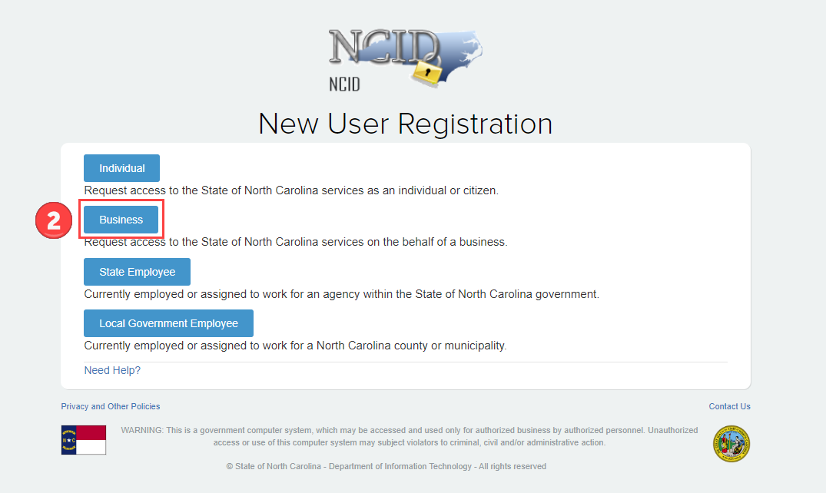
- Fill out all fields on the Register User form. Any field with a red asterisk (*) indicates a required field.
- Once all required fields are entered, click on the Save button.
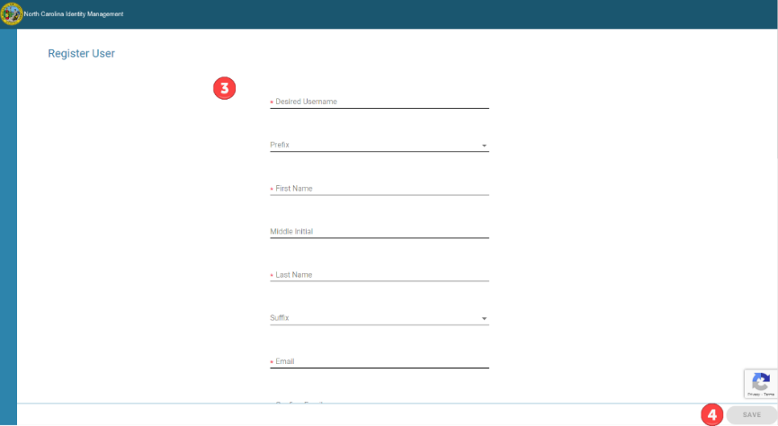
- Once approved, an email will be sent like the sample below. New users need to complete the account registration by confirming their email.
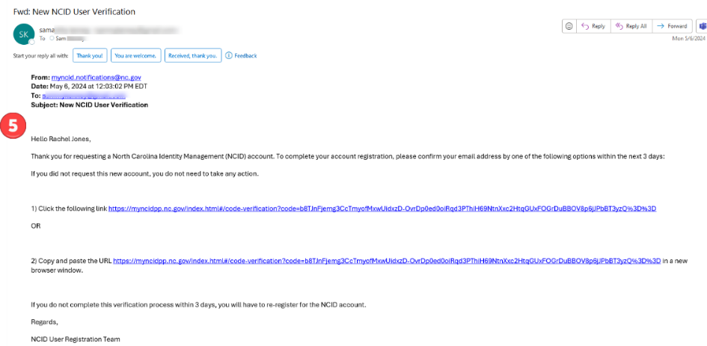
- Once confirming email associated with NCID account is completed, the NHA Provider Rep will login to Provider Portal using the following Link https://nhaproviderassessment.ncdhhs.gov/
- To login using an NCID account, click the NCID button.
- To download the Login Manual, use the link at the header or footer of the webpage.

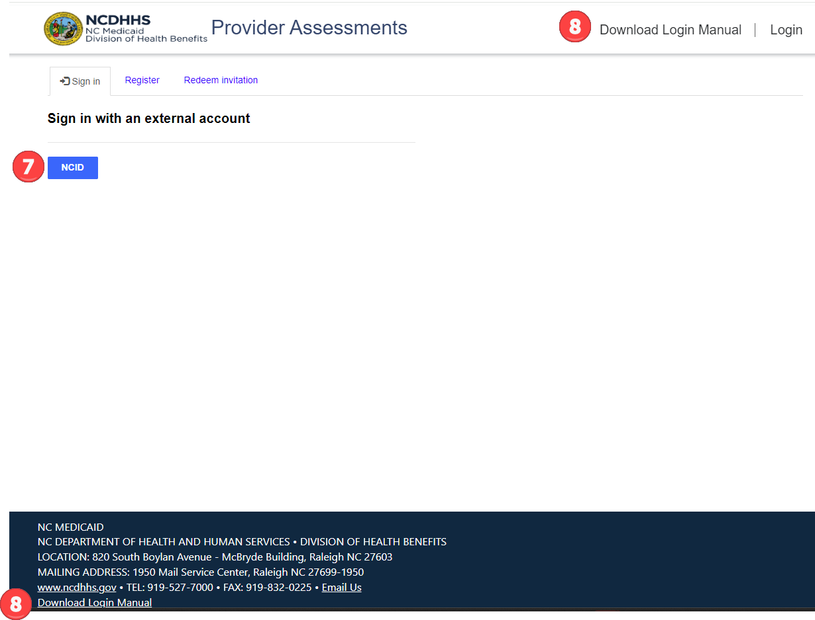

- The new NCID user will be directed to an MS Access Manager page to confirm linkage of their NCID profile to the NHA Provider Portal. Click on Yes.
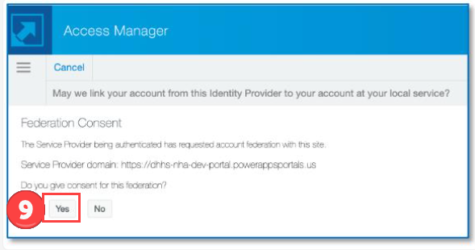

- Once Yes is selected, the New NHA Provider Representative will be brought to the User Profile screen. Please go to section 1.2.1 Setting Up User Profile: First Time Logging In as you need to be approved in the Portal as a new user.
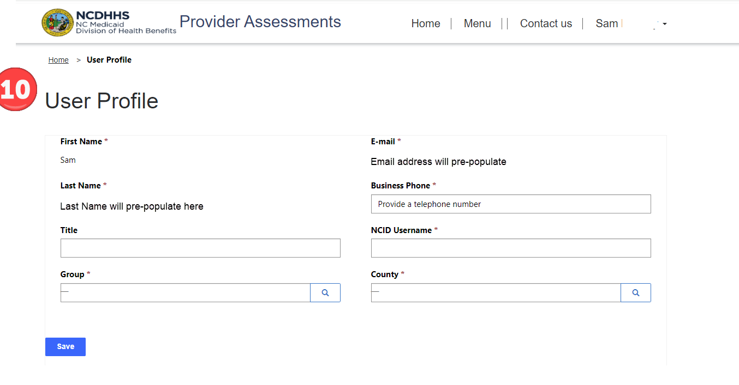

1.2.1 Setting Up Provider Rep User Profile: First Time Logging In
Once NHA Provider Reps have successfully signed in, they will be presented with the User Profile screen. Each NHA Provider Rep must complete their User Profile during their initial login. The steps to complete this process are:
- First Name, Last Name, and E-mail address will pre-populate from the information provided by NCID. These fields are not editable.
- Group, Business Phone, NCID Username and County are all required. Any field throughout the portal with a red asterisk (*) indicates a required field. The NCID Username is for informational purposes only to assist with troubleshooting. Changing the NCID username here will not alter your actual NCID username.
- Group and County are lookup fields which are indicated by magnifying glass button .
Once you have clicked on the magnifying glass button, the Lookup records screen will appear for selection.
- A search box is available for quickly finding any lookup record.
- All groups accessible to the currently signed-in NHA Provider Representative will be available for selection. At this point, the NHA Provider Representative only needs to select one group. Regardless of the group chosen, they will retain access to all authorized groups within the portal.
- Click the Select button (which will only become available once a group or county is picked) -- to save the selection.
- Click on Save once all required fields have been addressed.
- Click OK to submit the record.
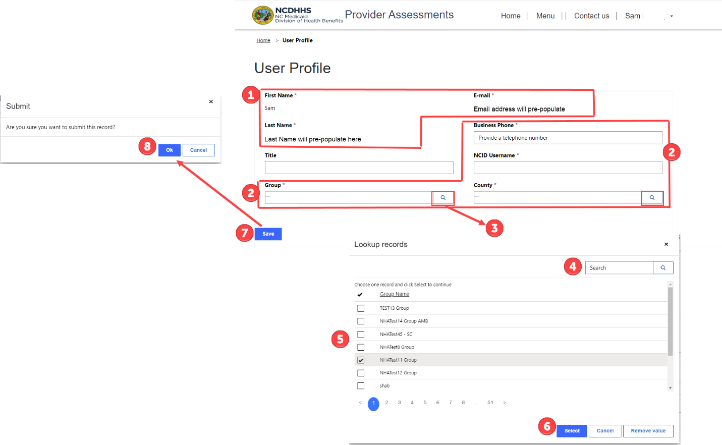

- NHA Provider Representatives should see the image below, indicating that their account is awaiting approval. Upon approval, they will receive an email confirming their account has been approved.
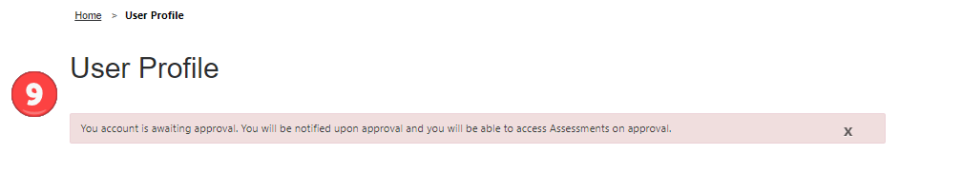
10. The NHA Provider Representative will receive a confirmation email upon approval. The NHA Provider Representative can then login using the hyperlink provided in the email or use https://nhaproviderassessment.ncdhhs.gov/
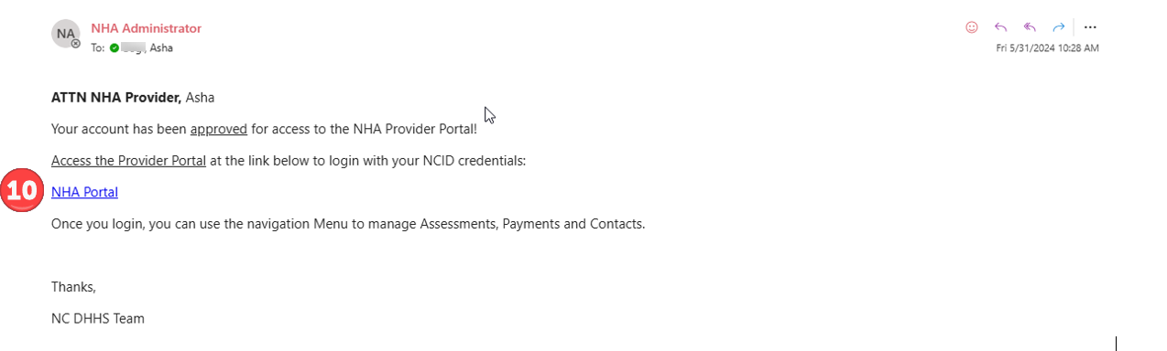
- On the NCID login page enter your NCID username and password.
- Click on NCID Login button.

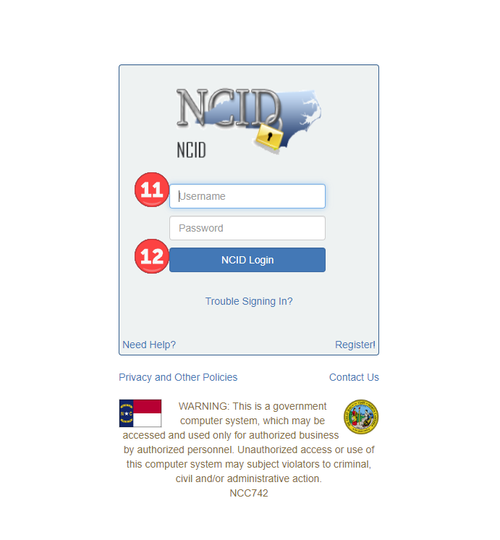
You have now successfully logged into the new Provider Portal using your NCID account.

What a NHA Provider Representative should do if they have any issue with the login process
- Please check all spam and junk folders in your email account to ensure the email is not missed.
- If you encounter any issues with logging in, please email Medicaid.HCAssessments@dhhs.nc.gov with the details of your problem. A NC DHHS staff member will assist you.

1.2.3 Logging into the NHA Provider Portal Post Setup
To access the Provider Portal after obtaining an NCID account and completing the Provider Portal setup, NHA Provider Representatives should follow these steps to log in:
- Click or copy and paste the following link into your browser. https://nhaproviderassessment.ncdhhs.gov/
- On the NCID login page enter your NCID username and password.
- Click on NCID Login button.
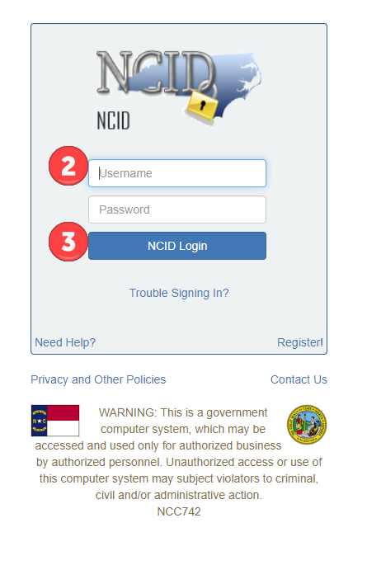
You have now successfully logged into the Provider Portal.

1.3 Accessing the NHA Provider Portal with existing NCID Account
Those with an existing NCID account, please follow the steps below to gain access to the new NHA Provider Portal.
- On June 3, 2024, all existing NCID accounts will receive an email to redeem and invite for Portal access. Click directly on the link provided in the email.
- The link will automatically bring you to the Redeem Invitation tab and auto populate the invitation code.
- ***IMPORTANT. Click the check box I have an existing account. Failure to do this will result in NCID creating a new account and will delay getting access to the new NHA Provider Portal.***
- Once you have checked, I have an existing account, click the Register button.
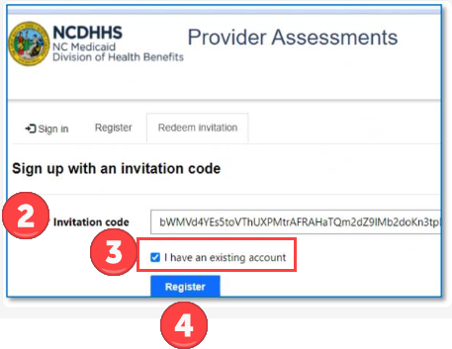
- On the NCID login page enter your NCID username and password.
- Click on NCID Login button.
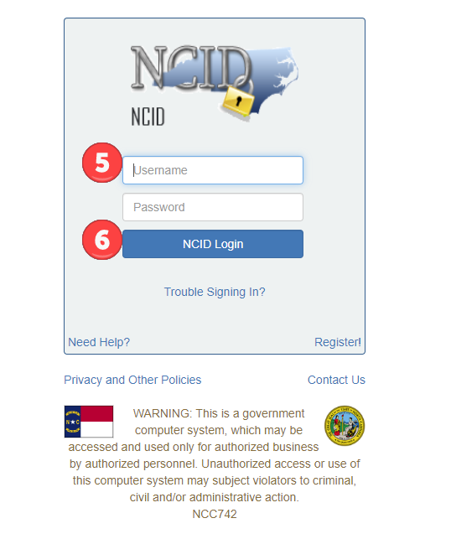
You have now successfully logged into the new Provider Portal using your NCID account. Please go to the next section 1.3.2 Setting Up User Profile: First Time Logging In as you need to be approved in the Portal as a new user.

1.3.1 What a NHA Provider Representative should do if they didn’t receive an email or have any issue with the login process
- Please check all spam and junk folders in your email account to ensure the email is not missed.
- If you encounter any issues with logging in, please email Medicaid.HCAssessments@dhhs.nc.gov with the details of your problem. A NC DHHS staff member will assist you.

1.3.2 Setting Up User Profile: First Time Logging In
Once NHA Provider Reps have successfully signed in, they will be presented with the User Profile screen. Each NHA Provider Rep must complete their User Profile during their initial login. The steps to complete this process are:
- First Name, Last Name, and E-mail address will pre-populate from the information provided by NCID. These fields are not editable.
- Group, Business Phone, NCID Username and County are all required. Any field throughout the portal with a red asterisk (*) indicates a required field. The NCID Username is for informational purposes only to assist with troubleshooting. Changing the NCID username here will not alter your actual NCID username.
- Group and County are lookup fields which are indicated by magnifying glass button .
Once you have clicked on the magnifying glass button, the Lookup records screen will appear for selection.
- A search box is available for quickly finding any lookup record.
- All groups accessible to the currently signed-in NHA Provider Representative will be available for selection. At this point, the NHA Provider Representative only needs to select one group. Regardless of the group chosen, they will retain access to all authorized groups within the portal.
- Click the Select button (which will only become available once a group or county is picked) -- to save the selection.
- Click on Save once all required fields have been addressed.
- Click OK to submit the record.

- The NHA Provider Representative should see the image below, indicating that their account is awaiting approval. Upon approval, they will receive an email confirming their account has been approved.
- The NHA Provider Representative will receive a confirmation email upon approval. The Provider Rep can then login using the hyperlink provided in the email or use https://nhaproviderassessment.ncdhhs.gov/
- On the NCID login page enter your NCID username and password.
- Click on NCID Login button.

You have now successfully logged into the new Provider Portal using your NCID account.

1.3.3 Logging into the NHA Provider Portal Post Setup
To access the Provider Portal after obtaining an NCID account and completing the Provider Portal setup, NHA Provider Representatives should follow these steps to log in:
- Click or copy and paste the following link into your browser. https://nhaproviderassessment.ncdhhs.gov/
- On the NCID login page enter your NCID username and password.
- Click on NCID Login button.
You have now successfully logged into the Provider Portal.

1.4 Provider Portal Production URL

Provider Portal Production Link Is: https://nhaproviderassessment.ncdhhs.gov

